PHYS 202 … Practice Problems

Inductance … Part A

Problem #1.

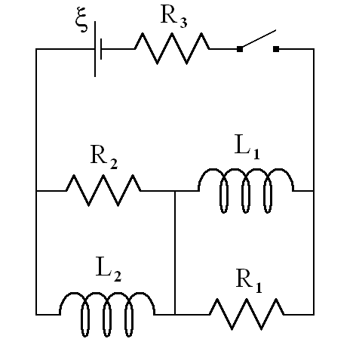

In the diagram shown above the ideal battery is 14.2 V, R1 = 16.0 , R2 = 12.0 , R3 = 14.0 , L1 = 35.0 mH, L2 = 50.0 mH. Initially the switch is open and no current is flowing anywhere in the circuit. The switch is closed at t = 0.

1. For t ≈ 0, what is the current in L1? 0
2. For t ≈ 0, what is the current in L2? 0
3. For t ≈ 0, what is the path of current through the circuit? Thru R2 then R1 then R3
4. For t ≈ 0, what is the current in R3? 0.338 A
5. For t ≈ 0, what is the current in R2? 0.338 A
6. For t ≈ 0, what is the current in R1? 0.338 A
7. For t ≈ 0, what is the voltage across R3? 4.73 V
8. For t ≈ 0, what is the voltage across R2? 4.06 V
9. For t ≈ 0, what is the voltage across R1? 5.41 V
10. For t ≈ 0, what is the voltage across L1? 5.41 V
11. For t ≈ 0, what is the voltage across L2? 4.06 V
12. For t ≈ 0, at what rate is the current in L1 changing? 155 A/s
13. For t ≈ 0, at what rate is the current in L2 changing? 81.1 A/s

Problem #2.



In the diagram shown above the ideal battery is 14.2 V, R1 = 16.0 , R2 = 12.0 , R3 = 14.0 , L1 = 35.0 mH, L2 = 50.0 mH. Answer the following questions based upon the switch having been closed for a long time.

1. At what rate is the current in L1 changing? 0
2. At what rate is the current in L2 changing? 0
3. What is the voltage across L1? 0
4. What is the voltage across L2? 0
5. What is the voltage across R1? 0
6. What is the voltage across R2? 0
7. What is the current in R1? 0
8. What is the current in R2? 0
9. What is the voltage across R3? 14.2 V
10. What is the current in R3? 1.01 A
11. What is the path of current through the circuit? Thru L2 then L1 then R3
12. What is the current in L1? 1.01 A
13. What is the current in L2? 1.01 A

Problem #3

A 340 mH inductor is connected in series with a 240  resistor. This combination is then connected to an ideal battery with an emf of 15.0 V.

1. Calculate the maximum current through the circuit.
2. Calculate the maximum potential energy that can be stored in the inductor for this circuit.
3. Calculate the time required for the current in the circuit to reach 2/3 the maximum value.
4. Calculate the time required for the potential energy in the inductor to reach 2/3 the maximum value.
5. 0.0625 A
6. 6.64 x 10 ‒4 J
7. 0.00156 s
8. 0.00240 s